MERCY PRESBYTERIAN CHURCH
ORDER OF WORSHIP

Sunday JUNE 23, 2019 10:30 AM

Call to worship Numbers 10:34-36
Pastor: And the cloud of the Lord was over them by day

People: Whenever they set out from the camp.

Pastor: And whenever the ark set out, Moses said,

People: “Arise, O Lord, and let your enemies be scattered, and let those who hate you flee before you.”

Pastor: And when it rested, he said,

People: “Return, O Lord, to the ten thousand thousands of Israel.”

prayer of invocation

hymn of adoration A Mighty Fortress Is Our God
4. That word above all earthly pow'r,
No thanks to them abideth;
The Spirit and the gifts are ours
through Him who with us sideth;
Let goods and kindred go,
This mortal life also;
The body they may kill;
God's truth abideth still,
His kingdom is forever!

Words and Music by Martin Luther
Public Domain

1. A mighty fortress is our God,
A bulwark never failing;
Our Helper, He amid the flood
Of mortal ills prevailing;
For still our ancient Foe
Doth seek to work us woe;
His craft and pow'r are great
And armed with cruel hate,
On earth is not his equal.

2. Did we in our own strength confide,
Our striving would be losing;
Were not the right Man on our side,
The Man of God's own choosing;
Dost ask who that may be?
Christ Jesus, it is He!
Lord Sabbaoth His name,
from age to age the same,
And He must win the battle.

3. And though this world with devils filled
Should threaten to undo us,
We will not fear, for God hath willed
His truth to triumph through us.
The prince of darkness grim,
We tremble not for him
His rage we can endure,
For lo his doom is sure
One little word shall fell him
NEW testament reading Acts 2:22-24, 36-37
²²”Men of Israel, hear these words: Jesus of Nazareth, a man attested to you by God with mighty works and wonders and signs that God did through him in your midst, as you yourselves know – ²³this Jesus, delivered up according to the definite plan and foreknowledge of God, you crucified and killed by the hands of lawless man. ²⁴God raised him up, loosing the pangs of death, because it was not possible for him to be held by it.
³⁶Let all the house of Israel therefore know for certain that God has made him both Lord and Christ, this Jesus whom you crucified.” ³⁷Now when they heard this they were cut to the heart, and said to Peter and the rest of the apostles, “Brothers, what shall we do?”

HYMN OF CONFESSION Guide Me O Thou Great Jehovah
Ending:
Land me safe on Canaan’s side
Bid my anxious fears
Bid my anxious fears
Land me safe on Canaan’s side
Bid my anxious fears
Bid my anxious fears (repeat all)
Goodbye (x3)

Authors: Words by William Williams,
Music by Jeremy Casella
© 2002 2037 Music

1. Guide me O Thou great Jehovah
Pilgrim through this barren land
I am weak but Thou art mighty
Hold me with Thy powerful hand
Bread of Heaven
Feed me now and evermore
Bread of Heaven
Feed me now and evermore

2. Open now the crystal fountain
Whence the healing stream doth flow
Let the fire and cloudy pillar
Lead me all my journey through
Strong Deliverer, be Thou still
My strength and shield
Strong Deliverer, be Thou still
My strength and shield

3. When I tread the verge of Jordan
Bid my anxious fears subside
Death of death, and hell’s destruction
Land me safe on Canaan's side
Songs of praises
I will ever give to Thee
Songs of praises
I will ever give to Thee

confession of sin
Lord God, we know with certainty that you have made Jesus both Lord and Christ. We rejoice that death and the grave could not hold Jesus. Yet we confess that it is because of us that Christ has been crucified. For the sins we have committed and will yet commit, Jesus Christ has suffered your wrath that we might be declared righteous. And so we are cut to the heart; our guilt and culpability remain only as wounds which mar the Chosen One. Move our hearts to repentance, pour out your Spirit upon us, and forgive us. Remove our guilt and let only peace remain. In Christ we pray, Amen.
assurance of pardon Acts 2:38-40
³⁸And Peter said to them, “Repent and be baptized every one of you in the name of Jesus Christ for the forgiveness of your sins, and you will receive the gift of the Holy Spirit. ³⁹For the promise is for you and for your children and for all who are far off, everyone whom the Lord our God calls to himself.” ⁴⁰And with many other words he bore witness and continued to exhort them, saying, “Save yourselves from this crooked generation.”

hymn of assurance Isaiah 43
1. When you pass through the waters, I will be with you
And the waves will not overcome you
Do not fear, for I have redeemed you
I have called you by name, you are mine

Chorus
Men: For I am the Lord your God (Women echo: I am the Lord your God)
I am the Lord your God
I am the Holy One of Israel, your Savior
Men: For I am the Lord your God (Women echo: I am the Lord your God)
I am the Lord your God
I am the Holy One of Israel, your Savior
Men: I am the Lord (Women: Do not Fear)
Men: I am the Lord (Women: Do not Fear)
Men: I am the Lord (Women: Do not Fear)
Men: I am the Lord (Women: Do not Fear)

2. When you walk through the fire, you’ll not be burned
And the flames will not consume you
Do not fear, for I have redeemed you
I have called you by name, you are mine

Chorus
I am the Lord.

Author Unknown, Public Domain

prayer of intercession

collection of tithes & offerings

hymn of thanks Joyful Noise by Ellie Holcomb
Mercy Presbyterian Church Vacation Bible School Children

(Children ages 4-5 are dismissed for “Equip for Worship” after the Hymn of Thanks.
Visitors’ children are welcome.)
Scripture Reading Numbers 10:11-13, 29-36
¹¹In the second year, in the second month, on the twentieth day of the month, the cloud lifted from over the tabernacle of the testimony, ¹²and the people of Israel set out by stages from the wilderness of Sinai. And the cloud settled down in the wilderness of Paran. ¹³They set out for the first time at the command of the Lord by Moses.
²⁹And Moses said to Hobab the son of Reuel the Midianite, Moses’ father-in-law, “We are setting out for the place of which the Lord said, ‘I will give it to you.’ Come with us, and we will do good to you, for the Lord has promised good to Israel.” ³⁰But he said to him, “I will not go.” I will depart to my own land and to my kindred.” ³¹And he said, “Please do not leave us, for you know where we should camp in the wilderness, and you will serve as eyes for us. ³²And if you do go with us, whatever good the Lord will do to us, the same will we do to you.”
³³So they set out from the mount of the Lord three days’ journey. And the ark of the covenant of the Lord went before them three days’ journey, to seek out a resting place for them. ³⁴And the cloud of the Lord was over them by day, whenever they set out from the camp.
³⁵And whenever the ark set out, Moses said, “Arise, O Lord, and let your enemies be scattered, and let those who hate you flee before you.” ³⁶And when it rested, he said, “Return, O Lord, to the ten thousand thousands of Israel.”

Sermon “The Journey as Part of the Destination”
Rev. Bryan Rigg

hymn of response Let Us Love and Sing and Wonder
4. Let us wonder grace and justice
Join and point to mercy’s store,
When through grace in Christ our trust is,
Justice smiles and asks no more.
He who washed us with His blood,
He who washed us with His blood,
He who washed us with His blood,
Has secured our way to God.

5. Let us praise and join the chorus
Of the saints enthroned on high.
Here they trusted Him before us
Now their praises fill the sky
Thou hast washed us with Thy blood,
Thou hast washed us with Thy blood,
Thou hast washed us with Thy blood,
Thou art worthy, Lamb of God.

Author: John Newton; Music by Laura Taylor
© Laura Taylor Music

1. Let us love and sing and wonder,
Let us praise the Savior's name.
He has hushed the law's loud thunder,
He has quenched Mount Sinai 's flame.
He has washed us with His blood,
He has washed us with His blood,
He has washed us with His blood,
He has brought us nigh to God.

2. Let us love the Lord who bought us,
Pitied us when enemies.
Called us by His grace and taught us,
Gave us ears and gave us eyes.
He has washed us with His blood,
He has washed us with His blood,
He has washed us with His blood,
He presents our souls to God

3. Let us sing though fierce temptation
Threatens hard to bear us down.
For the Lord our strong salvation
Holds in view the conqueror's crown.
He who washed us with His blood,
He who washed us with His blood,
He who washed us with His blood,
Soon will bring us home to God.

Benediction

Dismissal
Minister: Let us go forth to serve the world as those who love our Lord and Savior, Jesus Christ.

People: THANKS BE TO GOD!

Postlude

MERCY PRESBYTERIAN CHURCH CCLI LICENSE #11042946
Bryan Rigg, Associate Pastor 434-907-0711 (m) bryan@mercypres.org
P.O. Box 2564, Forest, VA 24551 Website: www.mercypres.org
Voicemail: (434) 237-1370 Emilee Ellsworth (Admin): emilee@mercypres.org
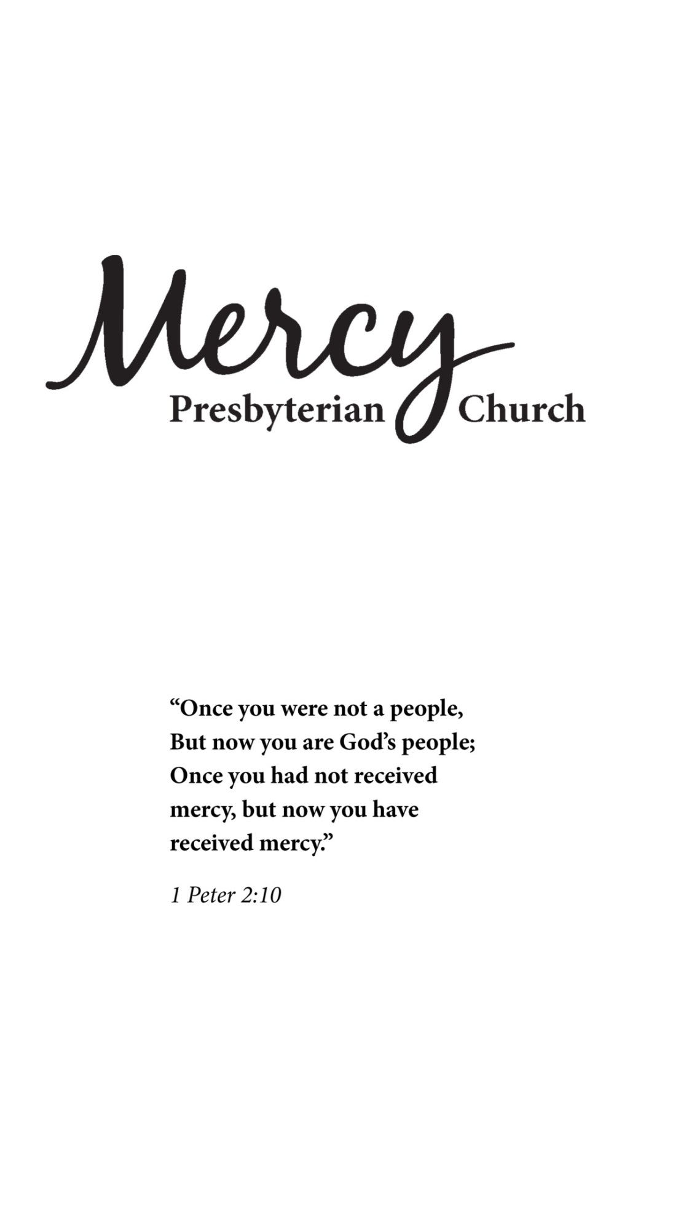

“Once you were not a people,
but now you are God's people;
Once you had not received mercy,
but now you have received mercy.”
I Peter 2:10

Presbyterian Church in America (PCA)

